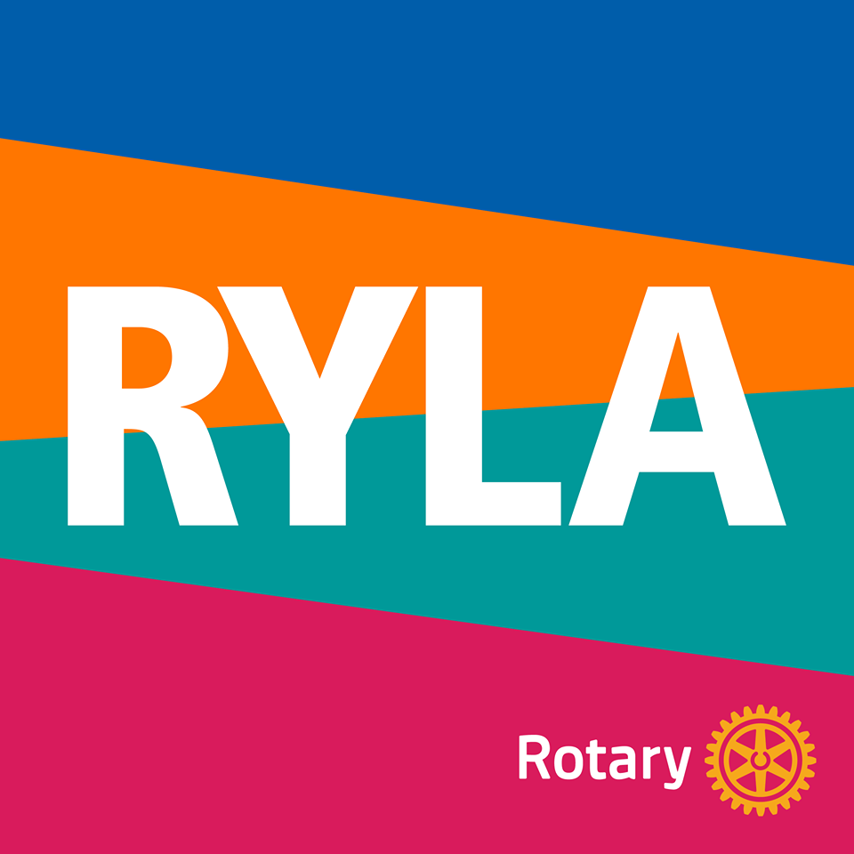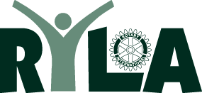

2022 RYLA TO-DO CHECKLIST FOR DISTRICT 6580 CLUBS
RYLA is: Friday October 21 – Sunday, October 23, 2022
√ Send completed 2022 Club Commitment Form to LOREN SNYDER, RYLA District Chair by due date of September 1, 2022 (Loren’s mailing/email addresses is on the Club Commitment Form)
√ Also Send Check for Participant Registration Fees to Loren no later than October 1, 2022
(make RYLA checks payable to Rotary District 6580). Cost is $200 per participant.
√ RYLA Paperwork Packet (5 documents total) must be completed by each participating student (and his/her parent) and submitted to Loren no later than October 1, 2019. Parent must sign as responsible party. RYLA Paperwork Packet is available for copy or download on the District Website. To access RYLA documents on our District Website, go to www.rotary6580/org, click on “Programs” then click on “Rotary Youth Leadership Awards.”
2022 RYLA Paperwork Packet includes the following 5 Documents:
1) 2022 RYLA Application (1 page) – both student and parent sign
2) Participant Medical Form (1 page) – parent signs
3) Bradford Woods Global Release (1 page) - parent signs
4) Rotary Photo Release Form (1 page) - both student and parent sign
5) Rules to Abide by While at RYLA Form (1 page) –both student and parent sign
√ Make direct contact with your local Interact Clubs and/or high school guidance counselors to
spread the word about RYLA and to encourage students to participate and sign-up. Share
the “WHAT is RYLA” info sheet with students, parents, teachers, counselors, etc.
√ Submit the participants’ completed and signed application and other paperwork by
the due date of October 1, 2022.
√ Consider volunteering or serving as a chaperone for this year’s RYLA! Contact Loren if
you would like to help with this year’s RYLA! You won’t regret it!
√ Contact RYLA District Chair Loren Snyder with any questions! Loren can be reached at lasnyder@rwbaird.com or cell (317)-407-1837. Let us know how we can help!

